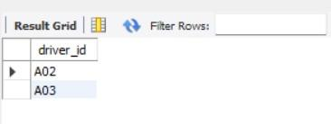

## **More Queries on Insurance Database**

### **Question (Week 2)**

* PERSON (driver_id: String, name: String, address: String)
* CAR (reg_num: String, model: String, year: int)
* ACCIDENT (report_num: int, accident_date: date, location: String)
* OWNS (driver_id: String, reg_num: String)
* PARTICIPATED (driver_id: String,reg_num: String, report_num: int, damage_amount: int)
* Create the above tables by properly specifying the primary keys and the foreign keys. **-** Enter at least five tuples for each relation
* Display Accident date and location
* Update the damage amount to 25000 for the car with a specific reg_num (example 'K A031181' ) for which the accident report number was 12.
* Add a new accident to the database.
* To Do
* Display Accident date and location
* Display driver_id who did accident with damage amount greater than or equal to Rs.25000

### **Schema Diagram**

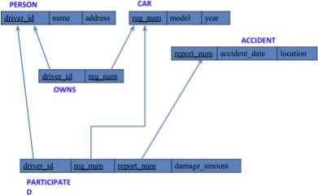

**Queries**

###### **Display the entire CAR relation in the ascending order of manufacturing year.**

select * from car **order by** year asc;

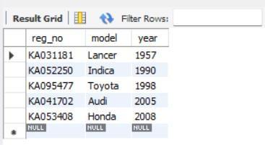

###### **Find the number of accidents in which cars belonging to a specific model (example 'Lancer') were involved.**

select model, **count**(**model**) **from** participated, car **where** participated.reg_no = car.reg_no

**group by** model;

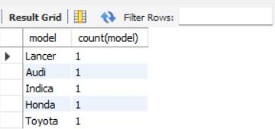

**TO DO:**

##### **FIND THE AVERAGE DAMAGE AMOUNT**

**select avg**(damage_amout) **as** average **from** participated;

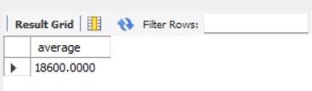

##### **DELETE THE TUPLE WHOSE DAMAGE AMOUNT IS BELOW THE AVERAGE DAMAGE AMOUNT**

**delete from** participated **where** damage_amt < (select * from (select

**avg**(damage_amount) **from** participated) **as** average);



##### **LIST THE NAME OF DRIVERS WHOSE DAMAGE IS GREATER THAN THE AVERAGE DAMAGE AMOUNT.**

**select** name from person, participated **where** person.driver_id = participated.driver_id and participated.damage_amount > (select **avg**(damage_amount) from participated);

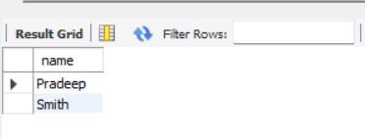

##### **FIND MAXIMUM DAMAGE AMOUNT.**

**select max**(damage_amount) **from** participated;

